Theory
Recursion is a programming technique in which a method calls itself to solve a smaller version of the same problem. A recursive solution consists of:
- Base Case – Stops the recursion.
- Recursive Case – Calls the same method with a smaller input.
Recursion simplifies problems that can be broken down into smaller subproblems.

Output

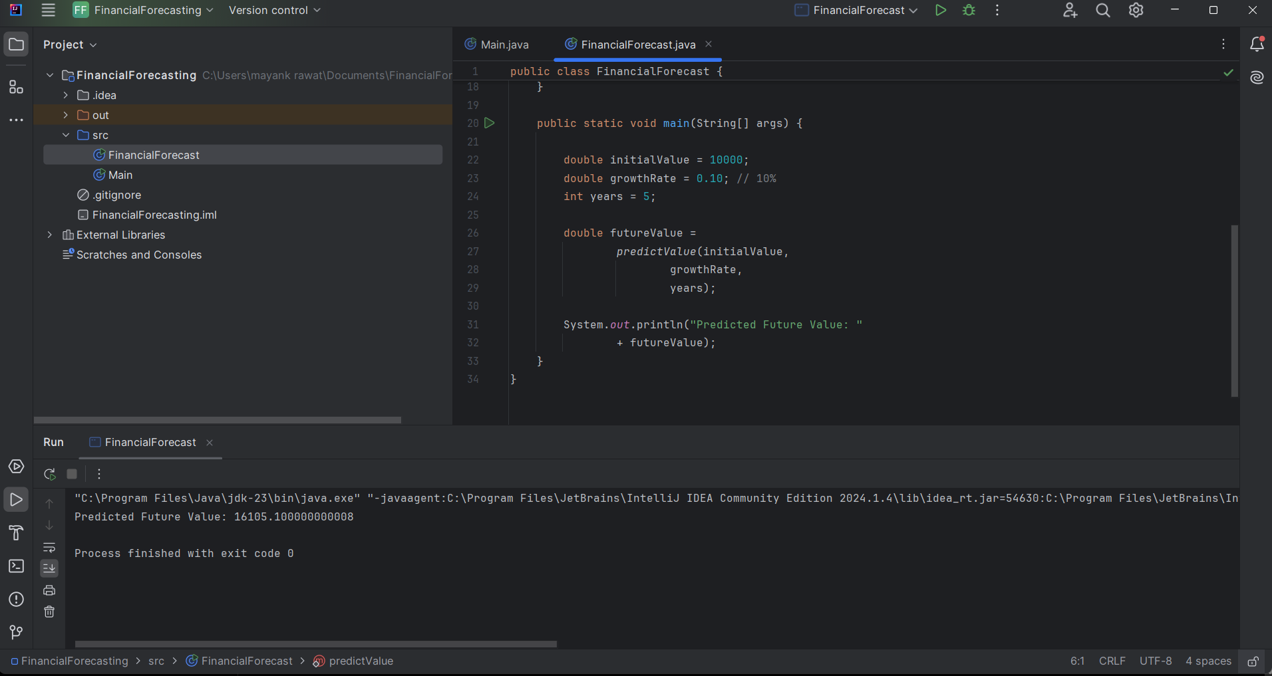

Code Implementation

public class FinancialForecast {
public static double predictValue(double currentValue, double growthRate, int years) {
// Base Case
if (years == 0) {
return currentValue;
}
// Recursive Call
return predictValue(currentValue * (1 + growthRate), growthRate, years - 1);
}

public static void main(String[] args) {
double initialValue = 10000;
double growthRate = 0.10; // 10%
int years = 5;
double futureValue = predictValue(initialValue, growthRate, years);
System.out.println("Predicted Future Value: " + futureValue);
}
}


Performance Analysis
The algorithm executes a single self-referential call for every annual increment.
Consequently, T(n) = T(n - 1) + O(1). This results in a Time Complexity of O(n) and a Space Complexity of O(n) due to the accumulation of method instances within the execution stack.

Optimization
The recursive solution can be optimized by:
- Use iteration instead of recursion to eliminate stack usage.
- Use Dynamic Programming (Memoization) for problems involving repeated calculations.
- Use the direct compound interest formula: Future Value = Present Value × (1 + Growth Rate)^Years.
Future Value = Present Value × (1 + Growth Rate)^Years
This avoids recursive calls and computes the result more efficiently.

